**Canonical issues – Technical**

**Problems:**

1. When search engines crawl many URLs with identical (or very similar) content, it can cause a number of SEO problems. Ex: Marketing content.
2. Ranking/Page Rank
3. Page Indexing issues

***Problems with URLs:***

search crawlers might be able to reach your homepage in all of the following ways:

http://www.fnbo.com

https: //www.fnbo.com

http:// fnbo.com

http://fnbo.com/index.html

<http://fnbo.com/index.html?q=personal> etc., many other ways.

For human, all of these URLs represent a single page. But the search crawler, though, every single one of these URLs is a unique "page." Even in this limited example, we can see there are five copies of the homepage in play. In reality, though, this is just a small sample of the variations you might encounter.

Modern content management systems (CMS) and dynamic, code-driven websites exacerbate the problem even more. Many sites automatically add tags, allow multiple paths (and URLs) to the same content, and add URL parameters for searches, sorts, currency options, etc. You may have thousands of duplicate URLs on your site and not even realize it.

Initial Status:

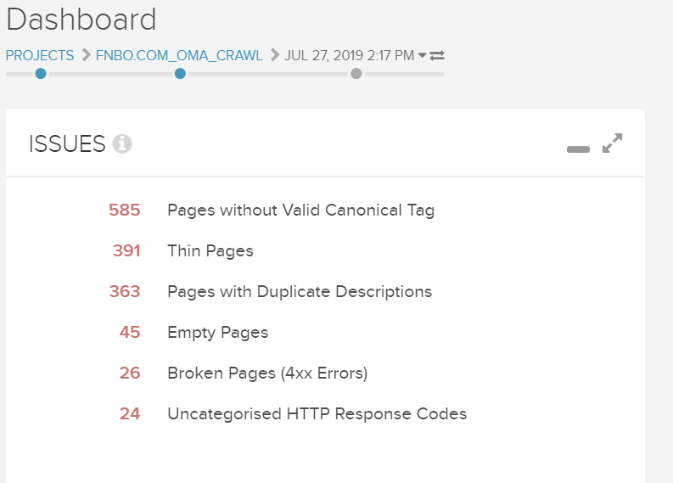

How the problem was identified?

We use conductor SEO to tool to monitor the SEO activities, deep crawl of the site enabled to identify the issues.

What is the solution?

Using canonicalization helps you control the content/page.

Traditional: Adding the tags to the code manually for all the pages.

Modern:

1. Dynamic tag injection using JavaScript.
2. Tag Manager

What are the major challenges to implement the solution?

TeamSite/ Estudio has certain limitations which doesn’t allow adding the canonicals.

What approach followed?

JS injection of Canonical URLs with self URL enabling the crawlers to identify the content on the page as original.

What is the solution?

Loading the canonical URLS for each individual page dynamically through main bundle JS file which was introduced to handle the jQuery updates problem.

What are the results? – Earlier and Now.

What is a Canonical tag?

A canonical tag (aka "rel canonical") is a way of telling search engines that a specific URL represents the master copy of a page. Using the canonical tag prevents problems caused by identical or "duplicate" content appearing on multiple URLs. Practically speaking, the canonical tag tells search engines which version of a URL you want to appear in search results.

Why it is important?

Duplicate content is a complicated subject, but when search engines crawl many URLs with identical (or very similar) content, it can cause a number of SEO problems. First, if search crawlers have to wade through too much duplicate content, they may miss some of your unique content. Second, large-scale duplication may dilute your ranking ability. Finally, even if your content does rank, search engines may pick the wrong URL as the "original." Using canonicalization helps you control your duplicate content.

What is the impact if not fixed?

What can we expect after adding the canonical tags?

1. Minimize some of the SEO problems
2. Improved content when search engine is crawling
3. Page indexing
4. Improvement in page ranking

Results:

Before:

FNBO:



First Bank Card:

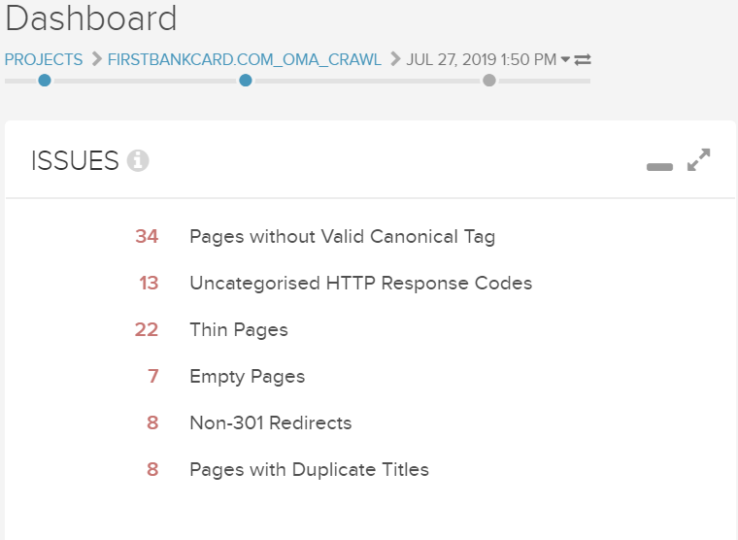

FNBO: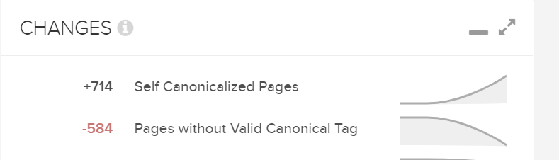

First Bank Card:

